Join the Minnesota SkiHawks
on a guided Italian bicycle tour.
October 7 – 16, 2024

The SkiHawks are going international! We will be partnering with Vermont Bicycle Tours (VBT) for this awesome trip. Our destination will be the Como Lakes region of north central Italy.
The price of the trip is $5,445 per person, double occupancy. A $350 deposit will reserve your spot.
The trip will include:
- Round trip air fare from MSP
- Ground transfers
- 8 nights of lodging
- 6-day bicycle tour
- Bicycle rental (e-bikes are available)
- Tour guides
- Support vehicle
- Cultural side trips and more
- 2-night pre & post trip extensions are available at a nominal charge
- Land only packages are available.
- Space is limited to 20 participants.
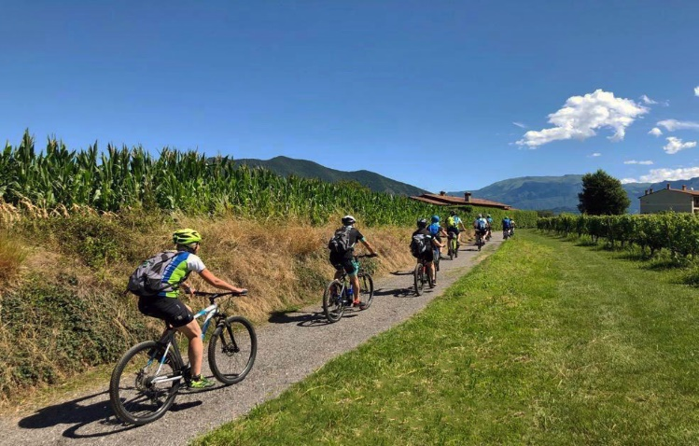
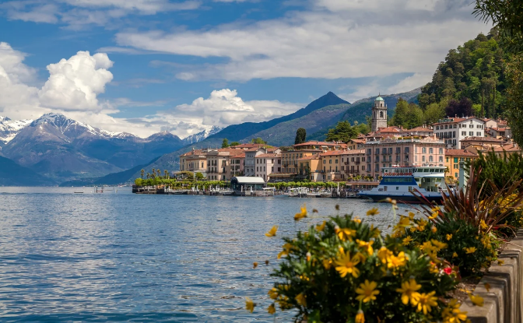

For more information:
- Contact your SkiHawk Trip Leaders:
- Susan Pfau (612) 770-9500 or susanpatskitrips11@gmail.com
- Pat Pfau: (612) 865-1234 or pjpfau11@gmail.com
- Visit MN SkiHawks.org Trips / Upcoming Trips for more information.
- Visit VBT at https://www.vbt.com/tours/italy-lake-como-the-italian-lake-district/ to view the tour itinerary, package inclusions, past trip reviews and more.
- Call a VBT Tour Consultant at (800)245-3868, Option 1. Our group number 338946.

To reserve your spot, for just a $350 deposit (refundable with conditions), contact a VBT Tour Consultant at the number above.

